Grade 3 Unit Plan

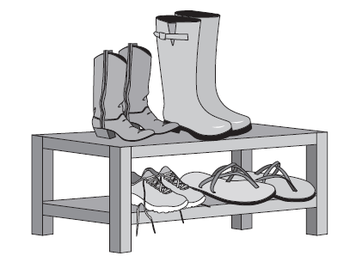
Working with Equal Groups
Introducing
Multiplication and
Division
Introduction: What is a unit plan?

A unit plan consists of:
- A narrative unit overview
- Lesson outlines
- A summative/end-of-unit assessment
- Student-facing work
This unit plan is a frame for an instructional unit. It represents one way that a unit of instruction may approach specific Common Core State Standards. The unit plan focuses on the key understandings and skills that students need to develop, but purposefully leaves more detailed instructional decisions to teachers and curriculum developers. Though the unit plan contains some examples and problems to use in class, details of the plan will need to be filled out by educators or publishers to develop complete instructional materials for the classroom.

The parts of a unit plan

Unit Overview:
The unit overview tells the instructional story of the unit. It also points out mathematical connections to content that might come before and after the unit.

Lesson Outlines:
The lesson outlines summarize what could happen in the classroom during math instruction to reach the learning goal of the lesson. A lesson that is based on one of the outlines might last for as little as half a class period or as many as 2–3 class periods, depending on the teacher’s judgment and the needs of the students. A significant part of the lesson outlines’ value is in the way they sequence the mathematics of the unit. In any unit, there are many decisions to make about how to sequence the material to be learned; within this unit, there is a progression of knowledge and skills that will allow students to meet the learning goals in the standards.

Each lesson outline includes:
- Alignment to the standards, including the lesson’s relationship to the Major Work of the grade and the aspect(s) of rigor targeted (conceptual understanding, procedural skill and fluency, and/or application)
- A description of the mathematics of the lesson, including connections to previous and subsequent lessons
- Connections between Standards for Mathematical Practice and Standards for Mathematical Content
- Concrete ideas for classroom problems, practice exercises and problem-based discussions, including answers
- Item analysis, highlighting potential student errors and misconceptions

The problems and exercises in a lesson outline are a sampling and are not meant to be exhaustive of all of the work students should do in class. Teachers can use the problems as models to create the full set of problems they will use with students.

End-of-Unit Assessment:
The end-of-unit assessment outlines what students should know and be able to do upon completion of the unit. Items on the assessment match the expectation for aspects of rigor called for by the standards in the unit. The assessment includes an answer key that notes alignment between the items and the lessons of the unit. Many assessment items align to multiple lessons as they target understanding that students are developing throughout the unit.

Student-facing Work:
A separate document is available that includes problems and questions to use with students. Teachers may use this document as a starting point for creating worksheets or use the problems for class discussions.

Table of Contents

Page Section
4 Unit Overview
What is this unit about?
Lessons and Learning Goals
Content Standards
Coherence
Mathematical Language

10 Lesson 1: Situations of Equal Groups: Introduction

14 Lesson 2: Multiplication terms and notations

18 Lesson 3: Analyzing situations of equal groups: Part 1

24 Lesson 4: Analyzing situations of equal groups: Part 2

28 Lesson 5: Fact Practice 1

31 Lesson 6: Situations of unknown group size

35 Lesson 7: Situations of unknown number of groups

39 Lesson 8: Division terms and notation

45 Lesson 9: Fact Practice 2

48 Lesson 10: Multiplying and diving to solve problems

53 Lesson 11: Fact Practice 3

55 Summative Assessment
Section 1: Fact Fluency
Section 2: Working with Equal Groups

What is this unit about?

In this unit, teachers introduce the fundamental concept of grade 3 multiplication, namely that $a × b$means the number of objects in a group of b objects each. (For generality in this overview, we have used letters to stand for arbitrary numbers, but teachers should use specific numbers in student-facing work.) Everything students do with multiplication in grade 3 follows from this one concept.

This fundamental concept of grade 3 multiplication may sound simple, however, there are many reasons for taking ample time to teach it. For example, many common real-world situations can be mapped onto the concept of equal groups, making multiplication a powerful way to solve a variety of word problems. Also, the language and notation of multiplication might be unfamiliar to students. Finally, the style of reasoning in the unit might be new, with students building up their knowledge logically and systematically based on a single fundamental concept. For all these reasons, teachers spend ample time during the first few lessons developing the fundamental concept of grade 3 multiplication.

A note about this unit:
The introduction of multiplication is one of several key moments in the Standards when a brand new idea is introduced to students. Although students have experience with the skills of skip counting, representing arrays with equations, and recognizing even and odd numbers in grade 2, none of these are strictly prerequisites for understanding multiplication and division. For this reason, references to skip counting and repeated addition are avoided when defining the operations. For more information about this topic, see: http://www.maa.org/external_archive/devlin/devlin_06_08.html

Although students at first use a variety of visual models in this unit, teachers should consistently show one type of model to represent multiplication and division problems throughout the unit. Sticking to a consistent model after lesson 3 will allow students to move from the model to a more abstract understanding of the operation. Note: the standards do not require that students be able to represent multiplication as jumps on a number line. No problems or exercises in this unit involve jumps on the number line, as the number line is not necessary in grade 3 work, except that which involves fractions.
One kind of equal-group situation is when you have an array, which means the objects are arranged in rows and columns, with the same number of objects in each row/column:

Arrays are common in real life – such as rows of seats in a theater – and moreover, arrays of dots are an economical way to represent products in early multiplication work. Arrays also set the stage for later grade 3 units that connect multiplication and area.
An array also makes it obvious why the value of a product is independent of the order of the factors:
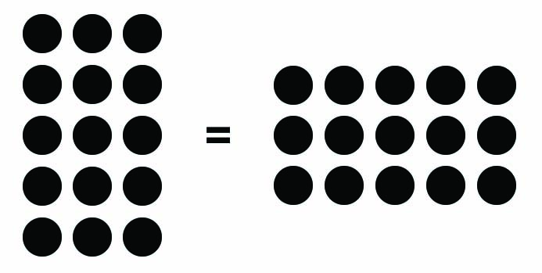
The commutative property of multiplication is not one of the topics explicitly targeted in this unit; commutativity is envisioned as being covered in a subsequent unit. However, students in this unit may ask about the order of the factors, and if the issue arises naturally, it is fine to tell students that the value of the product is the same regardless of the order of the factors (this can be justified quickly by a picture such as the above, or the justification can be deferred until a later unit). For this first experience with multiplication, the teacher should talk about the first factor in a product as the number of groups and the second factor as the number of objects in each group. A correct mathematical statement should never be called wrong, however, the teacher should be aware of whether students know which factor represents the number of groups and which represents the number of objects in each group.
Fluency is attended to throughout the unit, so that students will be set on the path to meet the year-end requirement of knowing single-digit products from memory and multiplying and dividing fluently within 100. Progress toward fluency is interwoven with students’ developing understanding of the meaning of multiplication and division. Lesson 5 is focused on accuracy of finding products. Lessons 9 and 11 continue the path to fluency by focusing on early facts, as outlined in the progression document:
Such fluency [for multiplying and dividing within the multiplication table] may be reached by becoming fluent for each number (e.g., the 2s, the 5s, etc.) and then extending the fluency to several, then all numbers mixed together. Organizing practice so that it focuses most heavily on understood but not yet fluent products and unknown factors can speed learning. To achieve this by the end of Grade 3, students must begin working toward fluency for the easy numbers as early as possible. (p. 27 of K Counting and Cardinality; K–5 Operations and Algebraic Thinking).
Although fluency work in this unit is focused on a relatively small set of facts, work throughout the unit uses the entire multiplication table within 100, and very large products are sometimes used to illustrate the concepts at hand. There are also products throughout the unit that involve a factor of 10. This connects multiplication to students’ understanding of the place value system.
The introduction of division is built on students’ understanding of multiplication. Division situations are introduced in lessons 7 and 8, and the symbolic notation is introduced in lesson 9. This approach allows students to make sense of both meanings of division (finding the number of equal groups or the number of objects in each equal group) before moving to the abstract level of the symbols.
There are a few special cases that are woven into the unit in order to ensure students are connecting them to their developing understanding. For example, multiplying with 0 is introduced in lesson 2, as students are asked to stretch their concept of multiplication (slightly) to include the case of 0 groups and the case of groups of 0 objects.
The Standards outline a variety of types of multiplication and division problems that students should be able to solve. (see table in lesson 10, excerpted from p. 89 of CCSS-M). Students in grade 3 solve problems involving ‘Equal Groups’ and ‘Arrays, Area’ situations with unknowns in all positions. ‘Compare’ situations are introduced in grade 4. Teachers should vary the situation types that students encounter in the unit.

A note about homework:
Although homework is not included in the unit plan, additional practice can be a key part of instruction. Well-designed homework allows students more time and opportunity to practice skills and concepts and allows parents to support their children’s practice. In this unit, it is recommended that teachers wait to give homework until lesson 5. At that point in the unit, homework can consist of practicing multiplication facts for accuracy and fluency, which is an ideal topic for parents to support.

Lessons and Learning Goals

Situations of equal groups
Identify and create situations of equal groups and describe these situations with formalized language

Multiplication terms and notation
Use mathematical terms and notation to describe situations of equal groups from the previous lesson

Analyzing situations of equal groups: Part 1
Translate between verbal descriptions, multiplication notation, and visual models to analyze situations of equal groups and solve problems

Analyzing situations of equal groups: Part 2
Describe arrays using multiplication notation

Fact Practice 1
Accurately determine products within 100 (for example, by skip-counting, knowing from memory, and other solution methods)

Situations of unknown group size
Identify situations of unknown group size, and describe these situations with formalized language
Find group size in situations

Situations of unknown number of groups
Identify situations of unknown number of groups and describe these situations with formalized language
Find the number of groups in situations
Distinguish between situations with unknown groups and an unknown number of groups

Division terms and notation
Translate between verbal descriptions, multiplication and division notation, and visual models to analyze division situations and solve problems

Fact Practice 2
Accurately determine products within 100 and their related quotients. Develop speed with 0, 1, 2, 5, and 10 facts

Multiplying and dividing to solve problems
Solve problems involving multiplication/division situations

Fact Practice 3
Accurately determine products within 100 and their related quotients
Develop speed with 0, 1, 2, 5, and 10 facts
Content Standards

Standards and clusters targeted in this unit:

- Major:
  - 3.OA.A. Represent and solve problems involving multiplication and division.
  - 3.OA.A.1 Interpret products of whole numbers, e.g., interpret 5 × 7 as the total number of objects in 5 groups of 7 objects each. For example, describe a context in which a total number of objects can be expressed as 5 × 7.
  - 3.OA.A.2 Interpret whole-number quotients of whole numbers, e.g., interpret 56 ÷ 8 as the number of objects in each share when 56 objects are partitioned equally into 8 shares, or as a number of shares when 56 objects are partitioned into equal shares of 8 objects each. For example, describe a context in which a number of shares or a number of groups can be expressed as 56 ÷ 8.
  - 3.OA.A.4 Determine the unknown whole number in a multiplication or division equation relating three whole numbers. For example, determine the unknown number that makes the equation true in each of the equations 8 × ? = 48, 5 = _ ÷ 3, 6 × 6 = ?.
  - 3.OA.B.6 Understand division as an unknown-factor problem. For example, find 32 ÷ 8 by finding the number that makes 32 when multiplied by 8.

Standards also addressed in this unit:

- Major:
- 3.OA.A.3 Use multiplication and division within 100 to solve word problems in situations involving equal groups, arrays, and measurement quantities, e.g., by using drawings and equations with a symbol for the unknown number to represent the problem.
- 3.OA.B.5 Apply properties of operations as strategies to multiply and divide. Examples: If 6 × 4 = 24 is known, then 4 × 6 = 24 is also known. (Commutative property of multiplication.) 3 × 5 × 2 can be found by 3 × 5 = 15, then 15 × 2 = 30, or by 5 × 2 = 10, then 3 × 10 = 30. (Associative property of multiplication.) Knowing that 8 × 5 = 40 and 8 × 2 = 16, one can find 8 × 7 as 8 × (5 + 2) = (8 × 5) + (8 × 2) = 40 + 16 = 56. (Distributive property.)
- 3.OA.C.7 Fluently multiply and divide within 100, using strategies such as the relationship between multiplication and division (e.g., knowing that 8 × 5 = 40, one knows 40 ÷ 5 = 8) or properties of operations. By the end of Grade 3, know from memory all products of two one-digit numbers.

- Supporting:
- 3.NBT.A.3 Multiply one-digit whole numbers by multiples of 10 in the range 10-90 (e.g., 9 × 80, 5 × 60) using strategies based on place value and properties of operations.

Coherence

Previous grades
In this unit, students use skills developed in previous grades, such as fluent addition, skip counting, place value understanding, and working with equations that have unknowns in various positions. Standards include:
- 1.OA.D
- 2.NBT.A.2
- 2.NBT.B.5
- 2.OA.C
- 2.OA.C.3
- 2.OA.C.4.

There are two important analogies between multiplication and addition:
- In multiplication the value of the product is independent of the order of the factors, just as in addition the value of the sum is independent of the order of the addends. (1.OA.B.3 and 3.OA.B.5)
- Division finds an unknown factor, just as subtraction finds an unknown addend. (1.OA.B.4 and 3.OA.B.6)

Later in grade 3
In later units, students will apply properties of multiplication as they develop fluency within the multiplication table. Students will also connect multiplication and area. Standards include:
- 3.MD.C.7
- 3.OA.D.8
- 3.OA.D.9
- 3.MD.A.2.

Future grades
In grade 4, students will learn the concept of “times as much,” including multiplicative comparisons, and extend procedural skill and fluency to work with multi-digit and fraction multiplication. In later grades, students will apply their understanding of multiplication and division to the entire rational number system. Standards include:
- 4.NBT.B
- 4.NF.B.4
- 4.OA.A.1
- 5.NF.B
- 6.NS.A
- 7.NS.A.2.
Mathematical Language

Some lessons, for example 2 and 8, contain a lot of new mathematical language for students. Students are not expected to master these new terms in one lesson, but will be given opportunities throughout the unit to hear and practice this language.

A note about mathematical language:
In the list below, variables are used for teacher reference only. In this unit, students sometimes work with equations with a single variable to represent an unknown value. In all other cases, specific values should be used.

General:
- Equal/unequal
- Factor
- Product
- Expression
- Equation
- Array
- Visual model
- Divisor
- Dividend
- Quotient
- Unknown factor

For expressions:
- a × b
  - The number of things in a equal groups of b [name of object] each
  - a times b
  - a multiplied by b
  - The product of a and b
- a ÷ b
  - The number of things in each group when a things are divided into b groups
  - The number of groups when a things are divided into groups of b objects each

For equations:
- a × b = c, c = a × b
  - the number of objects in a equal groups of b [name of object] each is c [name of object]
  - multiplying the factors a and b gives a product of c
  - a times b equals c
  - the product of a and b is c
- a ÷ b = c, c = a ÷ b
  - when a things are divided into b groups the number of objects in each group is c
  - when a things are divided into groups of b objects each, the number of groups is c
  - a divided by b equals c
Lesson 1
Situations of Equal Groups

Standard(s): 3.OA.A.1 (Major Work)

Learning goal/objective: Identify and create situations of equal groups and describe these situations with formalized language

Aspect(s) of rigor addressed: Conceptual Understanding

Overview
The first lesson in this unit is solely focused on the concept of equal groups. During class, the teacher and students use concrete objects and pictorial representations to examine a variety of situations involving equal and unequal groups.

Students will not be asked to find the total number of objects in this first lesson, nor will the word ‘multiplication’ be introduced, in order to maintain focus on the conceptual foundation of multiplication. Discussion and examples focus on situations of equal groups in everyday life, so students can begin to appreciate the need for multiplication. Large numbers, for which students would not be able to find the total, are used to keep the focus on understanding the operations (see problem #2.)

Equal groups are defined as arrangements where the quantity of objects in each group is the same. Students use the language ‘a equal groups of b [name of object(s)] each’ to describe the arrangements (e.g., 5 equal groups of 6 pencils each.) In this lesson, situations with groups of 10, groups of 1, and 1 group are introduced and will be revisited throughout the unit.

Opportunities to connect to Standards for Mathematical Practice:
Opportunities for students to construct viable arguments and critique the reasoning of others (MP.3) occur as students are working on understanding the difference between the number of groups and number in each group. Modeling with mathematics (MP.4) is elicited as students are representing equal groups with verbal expressions.

Tasks and discussion questions:
- Display 3 cups with 5 pencils in each cup and lead a discussion about whether the groups are equal. Ask the class how many groups there are and how many pencils are in each group. Present several examples including one where there are pencils with different characteristics. Ask the class whether specific characteristics of individual pencils (e.g., color, size) determine whether the groups of pencils are equal. Introduce the verbal expression ‘3 equal groups of 5 pencils each’ to represent the pencils.
- Have students create equal groups of concrete objects when given verbal expressions such as ‘4 equal groups of 10 cubes each.’
- Have students work with concrete or pictorial representations to determine if arrangements have an equal number of objects in each group and use the verbal expression to represent arrangements that do. Have students work with and discuss many examples, including the difference between 1 equal group of n objects each and n equal groups of 1 object each. Note: Students may write a variety of correct expressions to represent arrangements (see problem #3). Accept all responses from students who can justify their descriptions by showing the equal groups they can see. Discuss different ways of seeing the groups with the class, as appropriate.
- Summarize the lesson with a class discussion by asking:
  - If we were going to describe how many fingers the children in the room have, could we use an equal groups expression? Why or why not? What would it be?
  - If we were going to describe how many siblings the children in the room have, could we use an equal groups expression? Why or why not?

Challenges to anticipate:
- Students may confuse the number of groups and the number of objects in each group in the description of arrangements.
- Based on grade 2 work, students may confuse the terms “equal” and “even” and think that equal groups need to have an even number of objects.
- Students may think groups need to look exactly the same and not recognize that equal groups can have objects of different sizes, shapes, orientations or other attributes.

Lesson 1
Discussion, formative assessment and practice

1. Are the groups equal or unequal? If the groups are equal, describe, in words, how the objects are arranged.

a) 

equal unequal

4 equal groups of 3 books each

c) 

b) 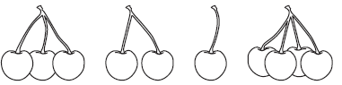

equal unequal

No expression, groups are not equal

equal unequal

4 equal groups of 1 cupcake each

2. Farmer Brown sells his eggs in packs of 12. In one month, he sold 1,349 packs. Use equal groups language to describe how many eggs he sold in a month.

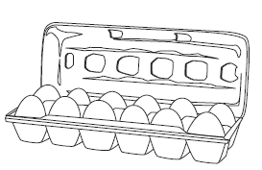

- 1,349 equal groups of 12 eggs each
- 1,349 equal packs of 12 eggs each

3. Are the groups of fingers equal or unequal? How many groups do you see? How many in each group?

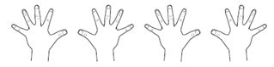

There are a variety of possible answers, some of which may be worth discussing with the class. Students only need to provide one correct explanation. Some correct expressions include:
- 4 equal groups of 5 fingers each
- 10 fingers in each group and 2 equal groups
- 1 group with 20 fingers
- 20 groups that each have 1 finger

Error Analysis
- Students may write 5 equal groups of 4 showing their confusion with the terminology. These students may need a reminder about the order of the expression so that they can correctly name the number of groups and the number in each group.
- Students may not recognize “20 equal groups of 1 finger” as a correct response. These students may have trouble seeing a group of 1 as a group. Students may need to be explicitly told that the mathematical definition of the word ‘group’ includes a group of 1. To reinforce the idea, show and discuss groups with one object (packs with 1 marker, tables with 1 student at each table, etc.).

Lesson 2

Multiplication terms and notation

Standard(s): 3.OA.A.1 (Major work)

Learning goal/objective: Use mathematical terms and notation to describe situations of equal groups from the previous lesson

Aspect(s) of rigor addressed: Conceptual Understanding

Overview
Lesson 2 introduces the terms and symbolic notation used to describe multiplication as equal groups. Students are introduced to the abbreviation a × b to represent the number of objects in a equal groups of b objects each. (Variables are used for teacher reference only. In student work, specific values should be used, unless a variable is necessary to stand for an unknown value.)

A note about multiplication terms and notation:
In this lesson, and throughout the unit, teachers should use the precise structure of the expression: the first factor represents the number of groups and the second factor represents the number of objects in each group. When students have a complete understanding of the commutative property, the structure for what each factor refers to will be relaxed.

Students will use symbols and mathematical terms to describe equal group situations in multiple ways (see examples in the tasks and discussion questions section below). The connection between the symbolic notation and the meaning of the terms is emphasized. Finding the product is introduced in the context of writing equations, but methods for finding the product are not discussed until later lessons. In this lesson, and throughout the unit, equations are presented with the product or quotient in different locations. Sometimes the product should come first in the equation to ensure students understand the equal sign (e.g., 30 = 5 × 6). In this lesson, the special case of having 0 objects in a group is introduced and will be revisited throughout the unit.

Opportunities to connect to Standards for Mathematical Practice:
With the introduction of the new terms ‘factor’ and ‘product’, the notation a × b for a equal groups of b objects, and the use of the equal sign, students practice using precise language and learn the meaning of the symbols being used. (MP.6) Working with symbolic notation, students recognize the connection between numbers and quantities, as well as, symbols and operations. These symbols allow students to create a representation of the arrangements of objects being presented. (MP.2)

Tasks and discussion questions:
- Review equal and unequal groups situations from lesson 1. Introduce the symbolic notation ‘×’ and the term 'multiplication' as a way to represent the situations from the previous lesson. Show the connections between the elements of the two expressions (verbal and symbolic). Introduce other ways to name the expression using words, including ‘a times b,’ ‘a groups of b,’ and ‘a multiplied by b.’
- Introduce the term ‘product’ and how to use an equation to describe arrangements of equal groups. Beginning with an equation that has a group size that is conducive to skip counting (e.g., objects in groups of 2s, 5s or 10s), ask students to find the product. Use the situation to model the equation (20 = 4 × 5 or 4 × 5 = 20) and mathematical language (‘the number of pencils in 4 equal groups of 5 pencils each is 20’, and ‘multiplying the factors 4 and 5 gives a product of 20’). Continue to ask students to describe what each part of the equation represents.
- Introduce groups of 0 objects by showing two empty containers and asking students how many pencils are in the containers. Use the equation (2 × 0 = 0) and the mathematical language (the number of pencils in 2 equal groups of 0 pencils each is 0 pencils) to discuss the special case of a factor of 0.
- Have students practice describing arrangements of equal groups with expressions, equations, and mathematical language. Practice includes questions that ask students to recognize the terms and symbols. Examples include groups of 1, 1 group, groups of 10, large numbers and unequal groups (to give more opportunities to discuss why the notation does not apply if the groups are not equal.) When working with unequal groups, ask: can we represent this arrangement using the multiplication symbol?

Challenges to anticipate:
- Students may reverse the order of the factors in the expressions or equations. At this point, it is important that students know which factor represents the number of groups and which factor represents the number of objects in each group.
- Students may think that the product always has to follow the equal sign, rather than understanding the meaning of the equal sign. (see 1.OA.D.7 Understand the meaning of the equal sign, and determine if equations involving addition and subtraction are true or false. For example, which of the following equations are true and which are false? 6 = 6, 7 = 8 – 1, 5 + 2 = 2 + 5, 4 + 1 = 5 + 2.)
- Students may write expressions when equations are required. Equations use the equal sign to define the equivalence of two or more expressions.

Lesson 2
Discussion, formative assessment and practice

1. Use symbols to describe the total number of legs on the spiders. Then represent the spider legs with words.



Symbols:
- 6× 8 = 48
- 6 × 8
Words: multiple possible answers including:
- six equal groups of eight legs each
- six equal groups of eight legs each is 48 legs
- 6 times 8
- six multiplied by eight
- the product of 6 and 8

2. Use the terms discussed during the lesson to properly name each number and symbol.

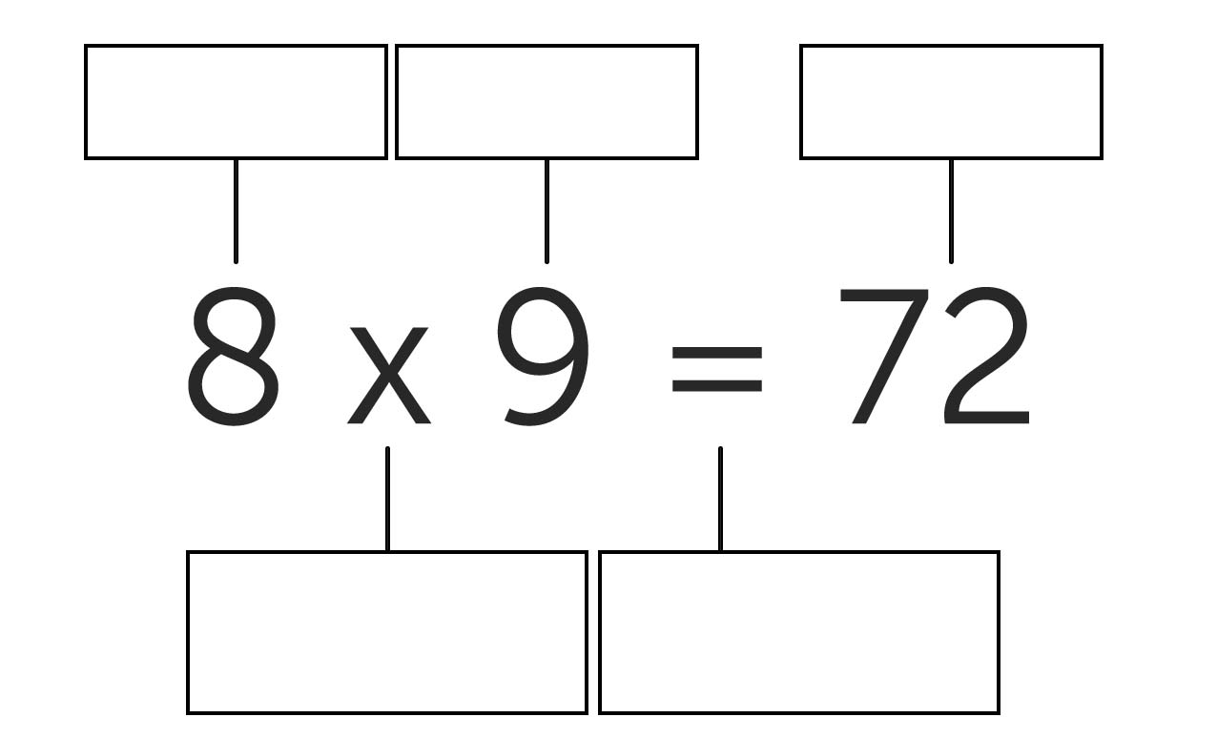
multiplication sign or times
equal sign or is the same as
factor
product
factor

3. Use the pencils to answer the questions below.

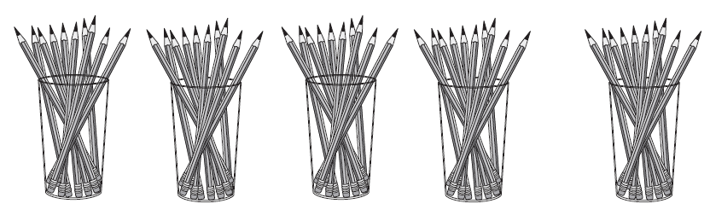

a) Write an equation to describe the arrangement of pencils.

5 × 10 = 50
b) What are the factors in the equation you wrote?

5 and 10

4. Circle the two correct ways to describe the number of dog legs.

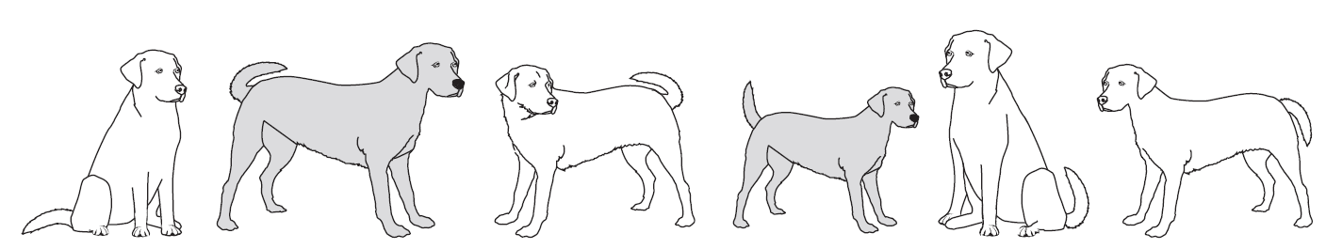

6 equal groups of 4 legs 4 × 6 24 = 6 × 4 4 groups of 6 is 24

Error Analysis:
- 6 equal groups of 4 legs - Correct. Each of the 6 dogs can be considered a group of 4 legs.
- 4 × 6 - Incorrect. Students who select this option may be struggling to use the precise definition of each factor; they may need more practice with distinguishing between the number of groups and the number in each group or where each is represented in expressions. Note: This answer could be correct if a student explains that they saw the grouping by legs as 1 group of 6 right hind legs, 1 group of 6 left hind legs, etc.
- 24 = 6 × 4 - Correct. Students who do not choose this option might think that the product always follows the equal sign in an equation.
- 4 groups of 6 is 24 - Incorrect. There are 6 groups, not 4 groups. Students who choose this answer may need more time to develop the language of groups introduced in lesson 1.

Lesson 3

Analyzing situations of equal groups: Part 1

Standard(s): 3.OA.A.1 (Major work)

Learning goal/objective: Translate between verbal descriptions, multiplication notation, and visual models to analyze situations of equal groups and solve problems

Aspect(s) of rigor addressed: Conceptual Understanding

Overview
Lesson 3 focuses on connecting multiplication situations to a variety of representations. Students have been describing arrangements of objects in previous lessons. In this lesson, they create visual models to represent equal groups situations and deepen their conceptual understanding of the operation of multiplication. The visual models that students create will likely be at different levels of abstraction and teachers should support their developing representations.

Within the lesson, students will be encouraged to create more abstract visual models that clearly represent the arrangement of objects in equal groups. This lesson begins the transition from working with concrete or named objects to abstract representation, while the focus remains on the structure of multiplication as equal groups. Building on their work in previous lessons, students will translate between real-world or mathematical situations, verbal expressions, multiplication notation, and visual models of equal groups. The work with visual models sets the stage for a specific visual model—the array—introduced in lesson 4.

Opportunities to connect to Standards for Mathematical Practice:
In making sense of real-world situations involving equal groups, students are required to model with mathematics, using visuals, language, and symbols. (MP.4)

Tasks and discussion questions:
- Share a real-world situation involving a small number of objects arranged in equal groups and have students create a visual model of the story (e.g., buying 3 packages that each contain 4 cupcakes.) Facilitate a discussion of students’ representations moving from the most concrete to the most abstract, focusing on similarities and differences between the representations. (See examples at the end of the lesson.) For each representation, ask: Does this visual model represent the arrangement in the story? How do you know?
- Introduce a model that shows the correct total but does not show the objects arranged in groups. Again, ask: Does this visual model represent the arrangement in the story? How do you know?
- Have students practice creating visual models for equal group situations with larger numbers, keeping within products less than 100, to encourage using more abstract representations. Practice includes interpreting and describing other students’ diagrams with symbols and mathematical terms learned in previous lessons. Questions to ask to encourage more abstract representations include:
  - Which visual model(s) clearly showed the arrangement? What made it clear?
  - Which visual model(s) didn’t communicate the type of objects being represented? Were you able to describe it with words and symbols anyway?
- Have students practice translating between situations, visual models, symbols, and mathematical terms. Situations should include, but aren’t limited to, groups of 1, 1 group, and groups of 10 (which can be connected to place value concepts.)
- Summarize the lesson by reviewing different representations of the same equal group situation. To review vocabulary from previous lessons, ask:
  - What is the product in this equation? What does it represent?
  - What are the factors in the equation? What do they represent?

Challenges to anticipate:
- Students may have trouble moving to abstract visual models.
- Students may have trouble recognizing and naming the arrangement in visual models created by others.
Lesson 3
Discussion, formative assessment and practice

1. Create a visual model that represents each multiplication situation.

a) 3 equal groups of 5 flowers each.



c) The product of 9 and 5

b) 6 × 10

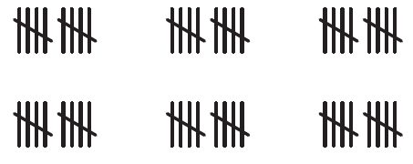

2. Use the images to answer the questions below.

a) Circle the two visual models that represent 6 × 3 = 18.





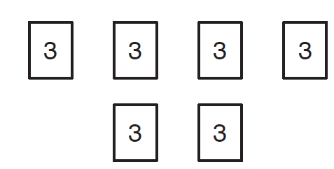



.

b) For the models that aren’t circled, explain why they do not represent the multiplication equation.

The tally marks show 3 groups of 6, not 6 groups of 3. There are 18 stars, but they show two groups of 9, not six groups of 3. Note: If students group the triangles in 6 groups of 3 triangles each, that answer can be considered correct.

3. Sally drew marks to represent groups of feathers. Describe the arrangement of feathers with words and with symbols. Include the product in your answer.



Words: Multiple correct answers, including:
- 10 groups of 3 feathers is 30 feathers
- 10 groups of 3 is 30
- the product of 10 and 3 equals 30
- 10 multiplied by 3 is 30
- 10 times 3 is 30

Symbols: 10 × 3 = 30

4. Describe a drawing that would show 695 × 843.

There is a variety of possible explanations, some of which may be worth discussing with the class. Students only need to provide one correct explanation. Some correct expressions include:
  - There would be 695 groups and each group would have 843 objects.
  - There would be 695 equal groups with 843 dots.
  - I would draw 843 dots in a group, and create 695 identical groups.

5. There are five rows of desks with six desks in each row.

a) Draw a picture to show the arrangement.

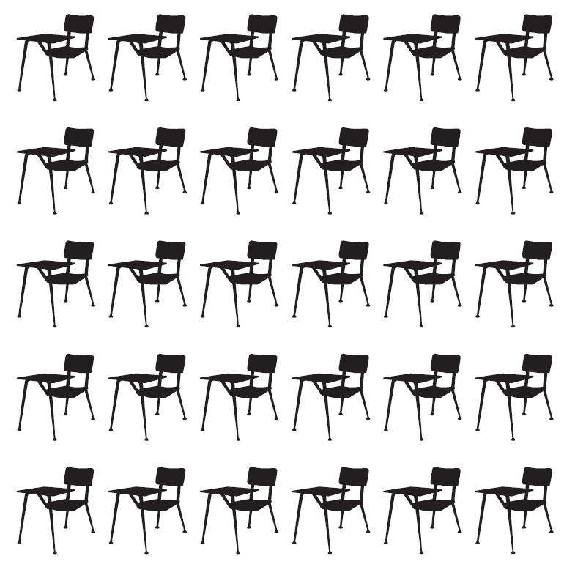
Any visual model that matches the description is correct.

b) How many chairs are there?

30

c) Write a multiplication equation that represents the situation.

5 × 6 = 30

Error analysis:
Part a: As students have been working to create abstract visual models, there is a range of visuals that students may create. Visual models do not need to represent the array, however student responses will give data to use to adapt lesson 4, if needed. Students who create arrays are already making a connection between the arrays they began to work with in grade 2 and multiplication. Errors that may occur:
- Students may create 6 groups of 5 desks. These students may need more instruction on differentiating between the number of groups and the number in each group.
- Students may not have 6 marks in every row. These students may need reminders and practice to ensure they can check the precision of their work.
- Students may not have a diagram that is recognizable as a multiplication situation because they are still having trouble moving to abstract visual models. These students may need more scaffolded examples to understand abstract models of real-world situations.
Part b and c:
- Students may reverse the factors. These students may need to revisit the sentence frame used in lesson 1.
- Students may write an incorrect total. This error is not a large concern at this point. Future lessons will help students develop accuracy in finding products.
- Based on work in grade 2, students may revert back to writing a repeated addition equation, as they did for previous work with arrays. It is important to remind students that they should now be using multiplication equations to describe situations of equal groups.

A note about visual models:
As students are creating visual models of multiplication situations, there will be a variety of responses. Throughout the unit, students should be moving towards more abstract and efficient models. Below are some examples of visual models that students may create, moving from concrete to abstract:

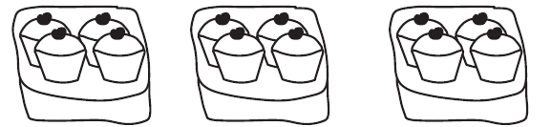





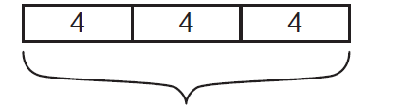

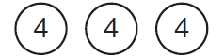

Lesson 4

Analyzing situations of equal groups: Part 2

Standard(s): 3.OA.A.1, 3.OA.B.5 (Major work)

Learning goal/objective: Describe arrays using multiplication notation

Aspect(s) of rigor addressed: Conceptual Understanding

Overview
Lesson 4 builds on students’ work with visual models of equal groups to develop an understanding of the specific structure of the array.

Work in this lesson builds on the experience students had in grade 2 with arrays (2.OA.C.4) to connect to the understanding of multiplication as equal groups. Arrays are defined as a particular arrangement of equal groups into equal rows and columns. To help students see the connection between equal groups of objects and arrays, arrays should be formatted so that the rows are clearly arranged as groups (see problem #1).

Students will see the convenience of arrays, which allow them to identify equal groups without counting each individual object. The structure of the array allows for the beginning of an ongoing discussion of the commutative property of multiplication, as the number of groups depends on the orientation of the array (e.g., an array with 3 columns and 4 rows has the same number of object as an array with 4 columns and 3 rows.) The expression that represents an array is defined by the orientation of the array. In this lesson, students and teachers should differentiate between an array of 4 × 2 and an array of 2 × 4, this distinction will go away in future work with arrays.



Opportunities to connect to Standards for Mathematical Practice:
In this lesson, students learn about the structure of an array and make connections to previous understandings and descriptions of equal group arrangements. (MP.7)

Tasks and discussion questions:
- Display an arrangement of objects in an array for discussion. Possible discussion questions include:
  - What do you notice about this arrangement of objects?
  - Are the objects in equal groups? How do you know? Do you have to count every object to make sure you have equal groups?
  - What do you remember about arrays from grade 2? How did you use arrays in grade 2?
- Have students practice using mathematical terms and symbols to describe arrays. Practice includes non-examples of arrays (e.g., arrangements with rows that do not have an equal number of objects), and arrays with 1 row, rows of 1 and rows of 10. Work includes two arrays that display the commutative property (e.g., 4 rows of 7 and 7 rows of 4).
- Have students create an array with counters to represent a product (e.g., 6 × 3). Expect that students will create arrays with 3 columns and 6 rows and some may create arrays with 3 rows and 6 columns. To help students make sense of what the expression means in the context of the array, possible discussion questions include:
  - How does your array show the factor of 6?
  - How does your array show the factor of 3?
  - How does your array show that 6 × 3 equals 18?
- Discuss two arrays that display the commutative property. Students are not explicitly learning commutative property at this time, however this is an opportunity to begin the discussion of patterns that some students will notice in their multiplication work. Possible discussion questions include:
  - How are the two arrays similar?
  - How are the two arrays different?
  - Can you describe other pairs of arrays that have similar characteristics?
- Have students practice naming arrays and building arrays with given dimensions.

Challenges to anticipate:
- Students may reverse the factors when writing the symbolic notation for arrays; Teachers should probe students to describe the groupings that they are seeing (e.g., describe each column as a group.)
Lesson 4
Discussion, formative assessment and practice

1. Use the image to answer the questions below.


a) Write an equation that represents the array.

4 × 5 = 20
b) What is the product in the equation you wrote?

20

2. Mr. Jones is buying tiles to retile his floor. Write an expression with two factors to show how many tiles he will need.

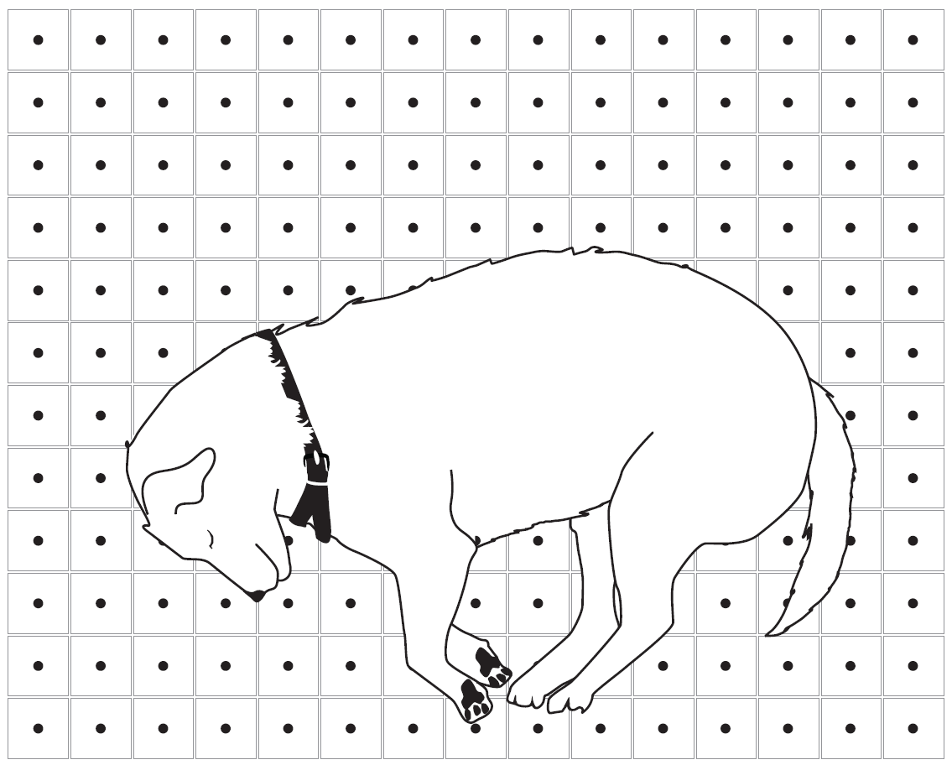

12 × 15

3. Samantha said “these arrays both represent 6 × 3, because they both show 18 dots.”



Do you agree or disagree with Samantha? Explain your answer.

The arrays do not both represent 6 × 3. Explanations might include:
- Only the first array shows 6 equal groups of 3 dots
- The second array shows 2 groups of 9.
- The second array shows 9 equal groups of 2

Error analysis:
- If a student thinks the arrays are the same, they may misunderstand the commutative property to think that all arrays with a given product are the same.
- If students’ explanations are unclear, they may need support with using precise language in explanations.

Lesson 5

Fact Practice 1

Standard(s): 3.OA.A.1, 3.OA.C.7 (Major work)

Learning goal/objective: Accurately determine products within 100 (for example, by skip-counting, knowing from memory, and other solution methods)

Aspect(s) of rigor addressed: Procedural Skill and Fluency, Conceptual Understanding

Overview
This lesson marks a transition point in the unit, in which students concentrate on accurately finding products. The first four lessons of the unit focused on developing the conceptual understanding of representing equal groups with the terms and symbols of multiplication, without always finding the product. This lesson, however, is entirely focused on accurately computing the product.

Students share methods of finding products while practicing a variety of facts. The goal throughout the lesson is consistent accuracy in answers. The lesson provides opportunities to have students share methods for accurately finding products. In later lessons and units, these methods will develop into strategies using properties of multiplication. Practice will include basic facts without context (e.g., 7 × 9 = _______ and _______ = 4 × 2) with the full range of products within 100. Throughout the lesson, students reflect on the efficiency of methods that lead to correct answers.

Opportunities to connect to Standards for Mathematical Practice:
As students work to calculate products accurately, they will draw on a variety of previous skills and understandings. Students may choose to use representations, concrete objects, skip counting, or they may just know some facts. (MP.5) During fact practice, some questions will be ordered so that students can begin to use repeated reasoning to find shortcuts for some problems (e.g., 5 × 6 is followed by 6 × 6, so students may compute 5 × 6 = 30 and then add 6 to find the product 36.) (MP.8)

Tasks and discussion questions:
- Present a multiplication problem that will allow students to have different methods to figure out the product (e.g., 3 × 5.) Have students share methods they used to figure out the total; some may know 3×5 from memory, some may skip count, some may use repeated addition, and some may create a visual model and count all or count on. NOTE: Students will likely be displaying a variety of strategies for finding products. Throughout this lesson, and later fluency-focused lessons, encourage students to move to more efficient strategies based on their conceptual understanding of the operation.

- Give students extensive practice accurately computing products and recording their work. Students should work with all single-digit facts with products within 100 (see problems and activities.) As they practice finding products, continue to reinforce that the first factor represents the number of groups and the second factor represents the number of objects in each group to support students’ understanding of a × b representing a equal groups of b objects each. Students should get feedback on the accuracy of their answers from peers or the teacher. Tools such as concrete objects, drawings, arrays, grid paper, etc., should be made available for students to choose to support their work as needed.
- Discuss how students accurately determined products. Ask:
  - Which products were easiest for you to find? Why?
  - Were there any products you ‘just knew’?
  - Did you notice any patterns in the products?

Challenges to anticipate:
- Students who know facts from memory may feel compelled to create a representation of the problem, based on the previous work.
- Students may think they know facts from memory but may recall the wrong answer.
- Students may rely on an inefficient strategy in fear of getting the wrong answer.
- Students may need more time with contextual-based multiplication situations in order to represent expressions and find the product.

A note about activities to develop fluency:
Students should engage in games and activities that require them to build visual models of equal groups and figure out the total to practice accurately finding products. An example of one such game, ‘Circles and Stars,’ can be found here: http://teacher.scholastic.com/products/dothemath/pdfs/Sample_Teacher_Guide_Pt1.pdf If there are students who are ready to practice facts for accuracy and fluency, refer to sample activities in lesson 9.

Lesson 5
Discussion, formative assessment and practice

- Solve

a) 5 × 1 = 5

c) 56 = 7 × 8

e) 7 × 10 = 70

b) 6 × 8 = 48

d) 12 = 3 × 4

f) 10 × 7 = 70

Circle the 4 facts that were quickest for you to answer. Why were you able to find the correct answer quickly?

Answers will vary

Lesson 6

Situations of unknown
group size

Standard(s): 3.OA.A.2, 3.OA.A.4, 3.OA.B.6 (Major work)

Learning goal/objective: Identify situations of unknown group size, and describe these situations with formalized language. Find group size in situations.

Aspect(s) of rigor addressed: Conceptual Understanding

Overview
In lesson 6, students apply their understanding of multiplication to situations of unknown group size. Students will work with concrete objects to analyze situations of unknown group size and represent the situations with multiplication equations with missing factors. Students will also solve problems to find the size of groups. Although the terms and symbols of division are not introduced, the work of the lesson lays the foundation for understanding division. This structure is analogous to how students work with subtraction as unknown addend problems in grade 1. Special cases of 0 and 1 are analyzed. Some problems involve missing factors that students may know from memory at this point (e.g., multiples of 10, 2, or 5.)

A note about fluency practice:
Students should continue to work on finding products each day to continue to develop fluency as they solidify their understanding of the operations.

Opportunities to connect to Standards for Mathematical Practice:
As students create a representation of the problem and attend to the meaning of quantities, not just how to compute them, they are engaging in contextualizing and de-contextualizing. (MP.2) As students find missing factors, they will choose from tools that will help them, including concrete objects, pictures, arrays, skip counting, or known facts. (MP.5) Throughout the lesson, students need to use the precise definition of each factor (i.e., number of groups and group size) to represent the situations correctly. (MP.6)

Tasks and discussion questions:
- Begin by previewing the two types of division situations by sharing a real-world situation involving a known total number of objects that need to be divided into a given number of equal size groups and a real-world situation with a known total number of objects that need to be divided into equal groups of a given size. Briefly discuss the differences between these situations and those that students have been working with in the unit. It is not necessary to spend time finding the unknowns in these situations.
- Have students use concrete objects to model situations of unknown group size by sorting a given number of objects into a given number of equal groups. Model writing a missing factor multiplication equation to describe the models (e.g. for 18 objects divided into 3 groups, students record 3 × _______ = 18).
- Have students continue to model situations and then record missing factor equations to represent them, including groups of 1, 1 group, groups of 2s, 5s and 10s.
  - Discuss what each number represents and how students determined the number of objects in each group. Students recognize that the total amount represents the product and the number of groups represents the first factor. The missing factor is the second factor, which is the size of the each group.
  - Discuss student work and how missing factors were found. Ask: Were there any problems that you “just knew” the missing factor?
- Introduce the 0 case by introducing a real-world situation that corresponds to an equation with 0 as the product (e.g., four students are sharing no candy → 4 × ∆= 0). Possible questions to ask include:
  - How much candy will each kid get?
  - What does this equation mean?
  - What does the 4 represent? What does the 0 represent?
  - What value would make this equation true? Are there any other values that would make true?
  - Can you model this equation with objects? Why or why not?
Display an equation that cannot be true with 0 as the first factor (e.g., 0 × a = 7) and discuss, using the same questions. Emphasize that if we have 0 groups, the product must also be 0.
- Have students practice analyzing and creating visual models to represent missing factor multiplication equations. A few of the problems should dictate a certain visual model to use (e.g., create an array to represent 18 = 2 × _______ ) but the majority of the problems should allow students to solve based on their developing understanding of multiplication and recall of some facts.
- To summarize and set the stage for the next lesson, introduce an equation with an unknown number of groups (e.g., _______ × 4 = 32). Ask:
- How is this similar to the problems we solved today? How is it different?
- What does the missing factor represent?
- How would you find the missing factor?

Challenges to anticipate:
- Students may find the answer by making groups of the given size, rather than the given number of groups.
- Students might believe that there is a value that makes every equation true. Therefore, they will have difficulty understanding an equation such as _______ × 4 = 0 as having no solution.

Lesson 6
Discussion, formative assessment and practice

1. Sarah bought 48 candies and put the same number of candies in each of the goodie bags shown.

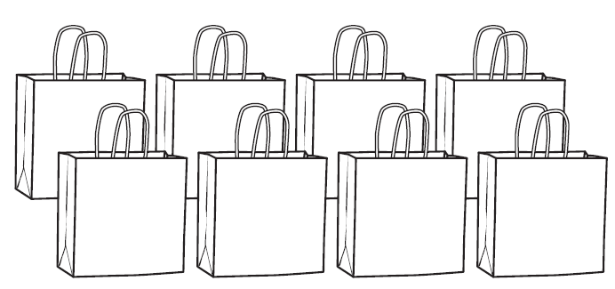

a) Write a multiplication equation to represent this problem.

- 8× __ = 48
- 8 × a = 48
b) How many candies did she put in each bag?

6 candies

2. Mr. Brown is arranging the 20 desks in his classroom in an array. He puts the desks into 5 rows. Each row has the same number of desks. How many desks are in each row?

4 desks

Create a visual model of the desks.

Possible visual models:

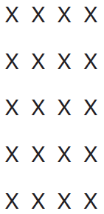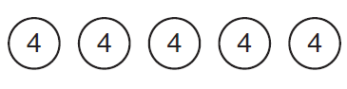

3. A class caught 56 bugs and wanted to put them in 7 jars. Each jar will have the same number of bugs.

a) Write a multiplication equation to represent this problem.

Correct equations include:
- 7 × ∆= 56
- 7 × n = 56
- 7 × 8 = 56.
Students do not need to find the missing value in the equation. A student who writes 7 × 8 = 56 is demonstrating strategies for finding quotients with bigger numbers.
b) They had 56 bugs, then caught 9 more bugs the next day. Write an equation to represent this problem.

Correct equations include:
- 56 + 9 = 65
- 9 + 56 = ___
- 56 + 9 = n

Error analysis:
Students who solved 3a incorrectly may have done one of the following:
- Students may write multiplication equations with the first factor missing (e.g., _______ × 7 = 56, n × 7 = 56). These students may need more instruction on differentiating between the number of groups and the number in each group.
- Students may use 56 as the number in each group (e.g., 7 × 56 = _______, 7 × 56 = n). These students may be having trouble understanding the meaning of the equal sign because they think that the unknown will always be to the right of the equal sign or they may need more instruction on differentiating between the total number and the number in each group.

Students who solved 3b incorrectly may write multiplication equations with a factor missing
(e.g., _______ × 9 = 56, n × 9 = 56). This error shows that students are overgeneralizing and may be applying multiplication to all word problems. These students may need more instruction and practice in decontextualizing word problems into one-step equations.
Lesson 7

Situations of unknown number of groups

Standard(s): 3.OA.A.2, 3.OA.A.4, 3.OA.B.6 (Major work)

Learning goal/objective: Identify situations of unknown number of groups and describe these situations with formalized language. Find the number of groups in situations. Distinguish between situations with unknown groups and an unknown number of groups

Aspect(s) of rigor addressed: Conceptual Understanding

Overview
Lesson 7 builds on the work with missing factors from the previous lesson, starting with situations of an unknown number of groups. Students work with concrete and pictorial representations and write them as missing factor equations. Practice includes groups of 1, groups of 0, and products up to 100 (with emphasis on 2, 5 and 10 to continue to develop fluency). Problems will also introduce measurement situations in which the units represent the objects in equal groups in order to build a foundation for later work with measurement. Towards the end of the lesson, students encounter both types of missing factor problems (unknown number of groups and unknown group size) to ensure that they are able to analyze, represent, and solve both types of problems.

Students should continue to work on finding products each day to continue to develop fluency as they solidify their understanding of the operations.

Opportunities to connect to Standards for Mathematical Practice:
By having students distinguish between different types of missing factor situations, there is a need for attention to precision when representing the unknown in multiplication equations. (MP.6) Noting and explaining the differences between the types of situations will require students to persevere to solve problems (MP.1) (see problem #2).

Tasks and discussion questions:
- Introduce situations of unknown number of groups by using concrete objects to sort a given number of objects into groups of a given size. Discussion questions might include:
  - How are these problems different from/similar to yesterday? How are you working with the objects differently?
  - What is the multiplication equation to represent this problem?
  - What does the missing number represent?
  - How did you find the value of the missing number? Is that the only value that will make it true?
  - Did you “just know” the missing factor in any of the problems?
Emphasize the reasoning behind the first factor being missing. (e.g., for 27 objects divided into groups of 9, students record 27 = _______ × 9). Students may notice that the value for the missing factor is the same, regardless of whether it represents the number of groups or group size; this is an observation that will be followed up in the next lesson.
- Using concrete objects, discuss situations with 0 objects in each group. Ask students to describe situations and represent them with an equation. Ask: how many total objects would we have with groups of 0? Display an equation with 0 as the second factor (e.g., _______ × 0 = 29) and discuss why there is no value that can make the equation true.
- Have students practice analyzing and creating visual models to represent missing factor multiplication equations, with both the first and second factor unknown. Basic measurement problems are included as a context (see problem #3). A few of the problems may dictate a certain visual model to use (e.g., create an array to represent _______ × 8 = 24) but the majority of the problems allow students to solve them based on their developing understanding of multiplication and recall of some facts. Students also have the opportunity to write about the differences between problems.
- Summarize the lesson by discussing the difference between the two types of division problems. Questions to ask might include:
- How are these situations the same? How are they different?
- How are the equations different?
- What kind of missing factor problems result in a product of 0?

Challenges to anticipate:
- Students may confuse which factor should be unknown in an equation because the placement of the unknown doesn’t matter when finding an answer. It is important for teachers to be precise and consistently identify the number of equal groups as the first factor, and the number in each group as the second factor. As students are developing their understanding of multiplication, they do not always need to correctly order the factors in the equations. However, students should be prompted to articulate the meaning of each factor by telling what it represents in the situation, regardless of the order.

Lesson 7
Discussion, formative assessment and practice

A note about problems in this lesson:
Some practice problems in this lesson should use the same factor and total presented in problems in lesson 6. This will allow for a discussion comparing the difference between the two problems (e.g., _______× 6 = 18 and 6 × _______ = 18) in the next lesson.

1. Your favorite marbles come in bags of 10. If you want to purchase 60 marbles, how many bags will you need to buy?

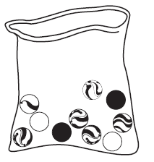

a) Write an equation to represent this problem.

- n × 10 = 60
- 6 × 10 = 60
- 60 = n × 10
b) Circle the number or symbol in your equation that tells how many bags you will need.

See bolded answers above

2. How many groups of 5 do you need to make 15? Explain how you know

3; Explanations will vary. Possible responses may include:
- representing the problem with a visual model
- describing using skip counting to solve
- explaining that 3 × 5 = 15 is a fact that they know
An answer such as “I know because 3 × 5 = 15” is better than “I know 5 + 5 + 5 = 15” because it demonstrates thinking that can be generalized to allow students to work with larger numbers
(e.g., 37 × ⌷ = 733).

3. Solve each problem and represent it with an equation. Draw a picture, if you think it will help.

a) Maria cuts 12 feet of ribbon into 3 equal pieces so she can share it with her two sisters. How long is each piece?

- 3 × 4 = 12
- 3 × _______ = 12

4 feet

b) Maria has 12 feet of ribbon and wants to wrap some gifts. Each gift needs 3 feet of ribbon. How many gifts can she wrap using the ribbon?

- 4 × 3 = 12
- △ × 3 = 12

4 gifts

4. Gina and Tim are arguing about which value makes the equation _______ × 0 = 0 true.
Gina says 9 will make it true, Tim says that 1 will make it true.
Who is correct Gina, Tim, both or neither? Explain your answer.

Sample answer: They are both right. Any value will make the equation true because no matter how many groups of 0 you have, the total is 0.

5. Answer the following questions.

a) Write a story that could be represented by the equation: 7 × 28 = c.

Any story that matches the equation. For example:
Each 3rd grade class at King Elementary has 28 students. If there are seven 3rd grade classes, how many 3rd graders are there?
b) Now, draw a visual model to represent
7 × 28 = c

Sample visual model:
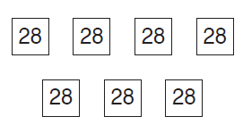

Error analysis:
This problem asks students to recall and apply concepts from previous lessons. As students have been working to create abstract visual models, there is a range of visuals that students may create. Errors that may occur:
- Students may create 7 groups of 4 or 4 groups of 7. These students may need more instruction on differentiating between the number of groups, the number in each group, and the total. It may be useful to reinforce the meaning of the equal sign to reinforce that 7 × 28 is equal to the missing number.
- Students may not attend to the placement of the equal sign and interpret the problem as _______ × 7 = 28. Sometimes, this error may occur from interpreting the equal sign as indicating the answer, rather than understanding it as signifying an equivalent relationship.
- Students may not represent 28 in each group. These students will need reminders about how to represent large numbers of objects abstractly.
- Students may not have a diagram that is recognizable as a multiplication situation because they are still having trouble moving to abstract visual models. These students need more scaffolded examples to understand abstract models of real-world situations.

Lesson 8

Division terms and notation

Standard(s): 3.OA.A.2, 3.OA.A.4 (Major work)

Learning goal/objective: Translate between verbal descriptions, multiplication and division notation, and visual models to analyze division situations and solve problems

Aspect(s) of rigor addressed: Conceptual Understanding

Overview
Lesson 8 introduces the mathematical terms and symbolic notation of division. Students use key terms and notation of division to describe both unknown group size and unknown number of groups. The connection between multiplication and division is used to help transition from representing division situations as missing factor equations to using formal division notation. Because c ÷ n means the unknown factor in
n × _______ = c or the unknown factor in _______ × n = c, therefore by previous work in multiplication, c ÷ n also means the number of things in each group or the number of groups; division finds unknown group size and unknown number of groups. Although both situations can be represented by the same expression, students should continue to think about the meaning of the numbers. The specific contexts of problems should help students determine how to represent and solve the problem.

Vocabulary is introduced in this lesson as a way to provide precise mathematical language for the concept that students have been working with in the two previous lessons. This is the first exposure to the division vocabulary that students will continue to use throughout this unit and beyond.

The special case of 0 as the divisor is analyzed in the context of division. Because 0 × _______ = 7 and
_______ × 0 = 7 are both impossible, therefore 7 ÷ 0 can’t be computed and is not defined. (There is no unknown factor that multiplies with 0 to yield 7. At the other extreme, 0 ÷ 0 is not defined because the unknown factor in 0 × _______ = 0 is not unique. Either way, division by zero is not defined.)

Students should continue to work on finding products each day to continue to develop fluency as they solidify their understanding of the operations.

Opportunities to connect to Standards for Mathematical Practice:
With the introduction of the terms divisor, dividend, quotient, and unknown factor and the division symbols, students will need to understand the relationship between the terms, symbols, and operations in order to be precise in their representations. (MP.6) As students relate these symbols to the different situations they worked with in previous lessons, they will be making sense of the structure of the operation. (MP.7)

Tasks and discussion questions:
- Review division situations from lessons 6 and 7. In the context of a missing factor equation, introduce the mathematical expression a ÷ b to describe the missing factor. (e.g. in a class of 27 students who are organized
into teams of 9, the expression 27 ÷ 9 represents the value of the missing factor in the equation a × 9 = 27.) Have students practice writing division expressions to represent the missing factor in multiplication equations. (See problem #1.)
- Revisiting situations from previous lessons, lead a discussion about two different missing factor equations that are represented by the same division equation (e.g., _______ × 6 = 18, 6 × _______ = 18, and 18 ÷ 6 = _______.) Discussion questions may include:
  - What do the given numbers in each equation represent?
  - What does the missing value in each equation represent?
Lead students to the understanding that a division expression finds both the unknown group size and the unknown number of groups. Introduce vocabulary terms students will be using to describe division equations including ‘divisor,’ ‘dividend’ and ‘quotient’.
- Have students practice using missing factor multiplication and division equations to describe situations. Students create visual models of division situations and equations.
- Review an unknown factor situation from lesson 6 or 7 that had a total of 0 objects. Students discover that if an unknown factor is 0, the product must also be 0. Lead students to the understanding that you can neither arrange a finite number of objects into groups of size 0 nor arrange objects into 0 groups.
- Have students practice describing expressions and equations that represent division situations. Practice includes questions that have students recognize the terms and symbols of division. Examples include making groups of 1, 1 group, groups of 10 and dividing 0 into groups. Some practice should include multiplication situations to ensure that students are able to use appropriate representations for both operations. (See problem #4.)

Challenges to anticipate:
- Students may generalize that the largest number is always the dividend in equations. Although this is true for most division equations students will see in grade 3, it is not true for 1 ÷ 1 = 1 and for future work students will do when dividing within the rational number system.
Lesson 8
Discussion, formative assessment and practice

1. Complete the multiplication problems below.

a) Given 4 × _______ = 12, write the related division equation

12 ÷ 4 =

c) Given 8 × _______ = 0, write the related division equation

0 ÷ 8 =

b) Given _______ × 6 = 18, write the related division equation

18 ÷ 6 =

d) Write two multiplication equations where the unknown factor is equivalent to 24 ÷ 6.

6 × _______ = 24 and 4 × _______ = 24

2. Your favorite marbles come in bags of 10. You want to purchase 60 marbles. How many bags will you need to buy?

a) Write a multiplication equation to represent the problem.

6 × 10 = 60

c) Write the answer.

6 bags
b) Write a division equation to represent the problem.

60 ÷ 10 = 6

3. Make 3 groups of 8 stars.



Write as many equations as you can to represent the arrangement of stars.

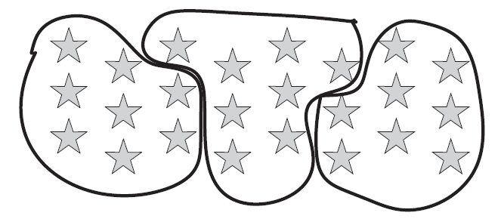

Correct answers include:
- 24 ÷ 8 = 3
- 24 ÷ 3 = 8
- 3 × 8 = 24

4. Suppose there are 4 tanks and 3 fish in each tank. The total number of fish in this situation can be expressed as 4 × 3 = 12.
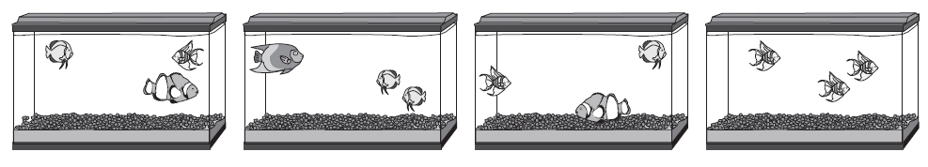

a) Describe what is meant in this situation by 12 ÷ 3= 4
Twelve fish divided into groups of three will need four tanks

b) Describe what is meant in this situation by 12 ÷ 4 = 3
Twelve fish divided into four tanks will have 3 fish in each tank

5. Complete the table.

Situation | Visual Model | Words | Symbols
Possible response:  Sonia is playing a card game where she needs to set out 3 rows with 15 cards in each row. How many cards does she have? | Possible responses:  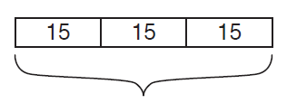   | the product of 3 and 15 is 45 | 3 × 15 = 45
Possible response:  Trevon made a promise to his parents that he would read every night for 28 days. How many weeks will he need to read? | 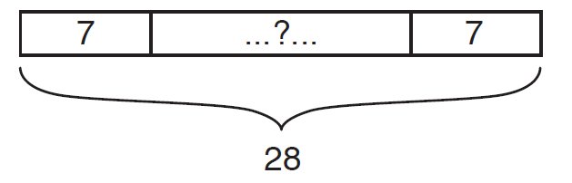 | Possible responses:  28 divided into equal groups of 7 each | Possible responses:  28 ÷ 7 = _______  28 ÷ 7 = 4  _______ × 7= 28  4 × 7 = 28
Mrs. Striker has 30 cookies to share equally with her reading class of 6 students. How many cookies will each student get? | Possible responses:  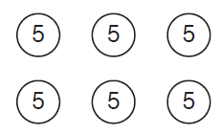  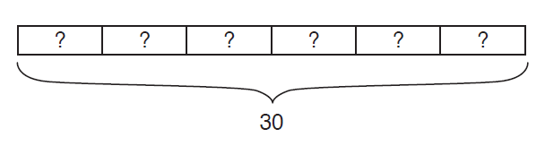 | Possible responses:  30 divided into 6 equal groups  30 divided by 6 | Possible responses:  30 ÷ 6 = _______  30 ÷ 6 = 5  6 × _______ = 30  6 × 5 = 30

6. Marco finds that 5 dozen eggs is equal to 60 eggs using the equation 60 = 5 × 12.

a) Write a division equation relating 5, 12, and 60.

- 60 ÷ 12 = 5
- 60 ÷ 5 = 12

c) What is the dividend in your equation? What does the dividend represent?

60
the total number of eggs

b) What is the divisor in your equation? What does the divisor represent?

12 or 5, depending on the equation
the number of eggs in a dozen or the number of dozens

d) What is the quotient in your equation? What does the quotient represent?

12 or 5
depending on the equation; the number of eggs in a dozen or the number of dozens

Error analysis:

- Students may write 5 ÷ 12 = 60 if they don’t understand what each number represents in a division equation or what the division symbol represents.
- It is likely that students may confuse the new vocabulary terms in this lesson. Teachers should use precise vocabulary and encourage students to do the same in future lessons.
Lesson 9

Fact Practice 2

Standard(s): 3.OA.C.7 (Major work)

Learning goal/objective: Accurately determine products within 100 and their related quotients. Develop speed with 0, 1, 2, 5, and 10 facts.

Aspect(s) of rigor addressed: Procedural Skill and Fluency

Overview
This lesson consists of fact practice, in which students are expected to begin developing fluency with certain facts. Class time invests students in the power and excitement of fluency and includes practice with a limited number of missing product, quotient, and factor problems. Practice is a mix of problems with products up to 100, with a particular focus on 0, 1, 2, 5, and 10 facts. The idea of commutativity is discussed in an effort to expand the range of facts that students know from memory. Within the lesson, students begin developing the ability to recognize facts for which they have methods for quickly answering (i.e. knowing from memory, skip counting, etc.)

Opportunities to connect to Standards for Mathematical Practice:
Students will use repeated reasoning (MP.8) to begin to develop speed with facts including numbers for which they know the skip counting sequence. Students will be discovering the commutative property of multiplication and using it to solve other problems (MP.7)

Tasks and discussion questions:
- Have students practice finding products within 100, with about half of the facts involving 0, 1, 2, 5, and 10. Problems are all numerical but are presented with a variety of values missing. Avoid using 0 ÷ 0 = _______ and 0 × _______ = 10, as these problems have infinite solutions and are therefore undefined. Discussion focuses on how students have quickly found the products.
- Display a missing factor problem using a variable to represent the unknown (e.g., a × 2 = 14). Questions for discussion may include:
  - What values of a make the equation true?
  - Are there any other values that would make the equation true?
  - What values of a make the equation not true?
  - How did you figure out the correct value of a?
- Display two problems from the practice that demonstrate the commutative property
(e.g., 3 × 5 = _______ and 5 × 3 = _______). Questions for discussion include:
  - What is the same about these problems? What is different?
  - What method would you use to find the product for each problem?
- Display a 5 × 3 array and ask students how to use it to find the product for both facts. Ask students: did the product change? Why not? Display another array and ask students to name two multiplication facts it could represent. Ask students to consider whether any two expressions with the same factors will have the same product.
- Summarize the lesson by creating a class or personal visual that allows students to start tracking which facts they know fluently. Keeping a multiplication table where students color in facts they have memorized will help build motivation and confidence as students are working towards fluency.

Challenges to anticipate:
- Students may not attend to the symbol and attempt to use multiplication to solve all problems.

A note about activities to develop fluency:
There are a variety of games and activities that will allow students to continue to develop both accuracy and fluency in finding products. A few examples are described below:
- Students can play ‘I Have, Who Has’, which requires students to listen for a fact that is equal to the product they have on their card. Materials can be easily created to customize this activity, but one sample set of cards can be found here: http://www.superteacherworksheets.com/multiplication/multiplication-ihavewhohas_TWZDR.pdf
- Students can play multiplication bingo, where students are identifying equivalent products and multiplication expressions. Teachers can adapt the board to focus on specific facts. Materials for bingo can be found here: http://www.scholastic.com/parents/resources/article/math-activities/multiplication-bingo
- Students can engage in games that randomly generate factors, which they use to write an expression and find the product. An example of a game that does this, called ‘Shake It Up’ can be found here: http://betterlesson.com/lesson/586512/shake-it-up-multiplication
- A variation of the random generation allows teachers to choose one of the factors in all the multiplication expressions. This game is useful to allow students ample practice with a specific set of facts. An example of this type of activity, called ‘Multiples Tic Tac Toe’ can be found here: https://drive.google.com/file/d/0B_wlnPzXZBUZcnk1eEpaQkFkTUk/edit
- Teachers can also ask teams of students to generate different equations using the same factor to continue to focus on a specific portion of multiplication facts. A game that requires this, called ‘Write a Different Fact’ can be found here: http://betterlesson.com/lesson/590745/write-a-different-fact-game?from=search_lesson_title
- Students can use flashcards to practice fluency and accuracy. Flashcards which allow students to practice both multiplication and division based on the relationships between the operations can be found here: http://www.superteacherworksheets.com/multiplication/fact-families-cards-multiplication_TZBBF.pdf

Lesson 9
Discussion, formative assessment and practice

1. Facts for speed and accuracy:

a) 3 × 5 = 15

c) 0 = 6 × 0

e) 70 = 7 × 10

g) 9 × 2 = 18
b) 10 $÷$1 = 10

d) 4 = 20 ÷ 5

f) 1 × 6 = 6

h) 0 × 5 = 0

2. Facts for accuracy:

a) 4 × 9 = 36

c) 27 $÷$3 = 9

e) 21 = 7 × 3

g) 0 ÷ 5 = 0
b) 9 = 3 × 3

d) 8 = 56 ÷ 7

f) 4 × 8 = 32

h) 24 = 3 × 8

Examining solution methods:
Students will likely be at very different places with their progression to fluency with facts involving 0, 1, 2, 5, and 10. Students will be moving between methods, with a goal of knowing from memory all single digit facts by the end of grade 3. Teachers should monitor where students are on the continuum of fluency and should help move students toward the ultimate goal of fluency by the end of the year. Some methods teachers may see include:
- Drawing representation of equal groups to find a product
- Using skip counting and mental addition accurately.
- Know facts from memory
The methods listed above fall into the definition of Level 1 and 2 strategies outlined in the ‘Progressions for the Common Core State Standards in Mathematics, K–5, Operations and Algebraic Thinking.’ For more detailed information on the levels that build to fluency, see:
http://commoncoretools.files.wordpress.com/2011/05/ccss_progression_cc_oa_k5_2011_05_302.pdf#page=25

Lesson 10

Multiplying and dividing to solve problems

Standard(s): 3.OA.A.1, 3.OA.A.2, 3.OA.A.3 (Major work)

Learning goal/objective: Solve problems involving multiplication/division situations

Aspect(s) of rigor addressed: Conceptual understanding, Application

Overview
Lesson 10 focuses on students recognizing, representing, and solving multiplication and division situations. Work builds directly on previous understandings in the unit, where students have worked with equal groups of objects in context. This lesson is a bridge between work with pictures, objects and contexts and the more structured application problems students will be engaging with throughout the year. Students solve problems reflecting a variety of situation types with unknown values in all positions and translate between stories, equations and visual models. Practice includes a variety of situation types involving equal groups and arrays, as outlined in Table 2 of the Standards (p. 89), also included at the end of the lesson. Problems are not necessarily classified as multiplication or division to encourage students to use the relationship between multiplication and division to solve and represent the problems.

In addition to the new work of the lesson, students should continue to work on accurately finding products, with a focus on developing fluency with 0, 1, 2, 5, and 10 facts.

Students should continue to work on finding products each day to continue to develop fluency as they solidify their understanding of the operations.

Opportunities to connect to Standards for Mathematical Practice:
This lesson focuses on students creating mathematical models for real-word situations of equal groups. (MP.4) By moving between their understanding of the operations of multiplication and division and contextual problems, students are reasoning abstractly and quantitatively. (MP.2)

Tasks and discussion questions:
- Have students solve a story problem. Questions for discussion may include:
  - What is happening in this situation?
  - Is this situation about equal groups? How do you know?
  - How does this relate to the other work we’ve done in this unit?
  - What quantities and relationships do we know?
  - What is the question asking you to find out?
  - What equation can we use to represent the problem? Is there more than one equation we can use?
  - How did you find the answer to the question? Did anyone find the answer differently?
If possible, highlight both multiplication and division equations and visual models that could be used to represent the problem.
- Have students practice solving problems related to a variety of situation types and practice writing questions that could be solved using multiplication or division to match given situations or pictures. In class discussion, highlight different answers to the problems, comparing and contrasting different approaches that led to the correct answer, as well as giving opportunities for revision to students who had incorrect answers.
- Summarize the lesson by reviewing various situation types and asking students to discuss the similarities and differences between the situations and potential methods for solving them.

Challenges to anticipate:
- Students may have trouble interpreting what the questions are asking in story problems. Encourage these students to use visual models to help understand the actions in the story, transfer all the given information to the model and use the model to write multiplication and division equations.
- Students may have trouble solving problems when confronted with unfamiliar contexts or language within the problems.

Table 2:

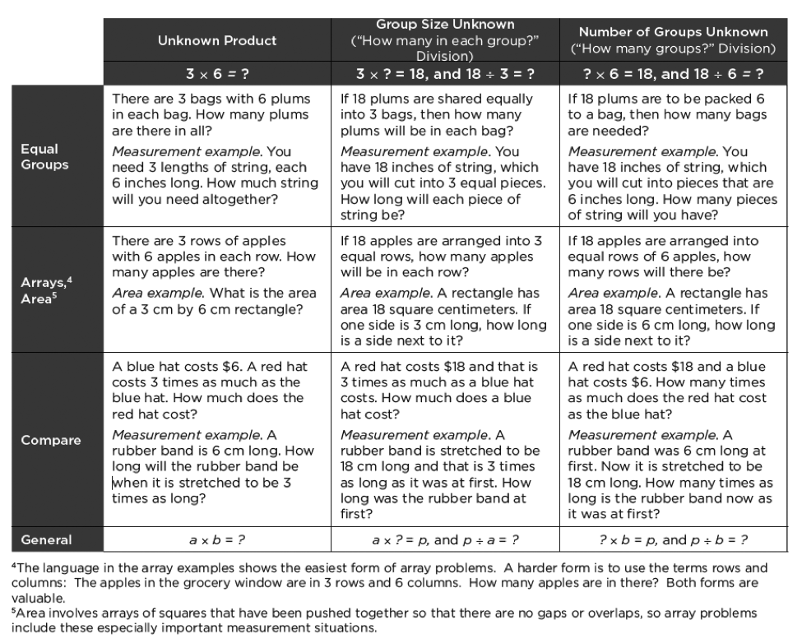

A note about situation types:
Students in Grade 3 are only responsible for “Equal Groups” and “Arrays, Area” situation types. “Multiplicative Compare problems appear first in Grade 4, with whole-number values for A, B, and C, and with the “times as much” language in the table. In Grade 5, unit fractions language such as “one third as much” may be used. Multiplying and unit fraction language change the subject of the comparing sentence, e.g., “A red hat costs A times as much as the blue hat” results in the same comparison as “A blue hat costs 1/A times as much as the red hat,” but has a different subject.” (Progression on Counting and Cardinality and Operations and Algebraic Thinking, p. 23)
Lesson 10
Discussion, formative assessment and practice

1. For each problem, write an equation and give the answer. You can draw a visual model if you think it will help you.

a) Liam is baking cookies. The recipe says you need 2 cups of sugar in each batch of cookies. Liam needs to make 4 batches of cookies. How many cups of sugar will he need?

Correct equations include:
- 4 × 2 = 8
- 4 × 2 = ___
8 cups

c) Nina bought 12 apples. She needs to use 3 apples in each batch of muffins she makes. How many batches of muffins can she make?

Correct equations include:
- ___ × 3 = 12
b) Liam bought 5 bunches of bananas. Each bunch has exactly 5 bananas. How many bananas does Liam have?

Correct equations include:
- 5 × 5 = 25
- 5 × 5 = ___
25 bananas
- 4 × 3 = 12
- 12 ÷ 3= ___
- 12 ÷ 3 = 4
4 batches of muffins

d) Owen is building a rectangular tile patio that is 4 tiles wide and 6 tiles long. Tiles come in packs of 12 each. How many packs of tiles does he need to buy?

Correct equations include:
- 4 × 6 = 24
- 24 ÷ 12 = 2
- ___ ×12 = 24
2 packages

2. For each picture, write a question that would require multiplication or division to answer.

a)

Sample answers:
- How many shoes are on the rack?
- Each member of Trevor’s family has a shoe rack with 8 shoes on it. If there are 5 people in his family, how many shoes are on their racks?
b)


Sample answers:
- There are 35 balls in each bag. How many balls are in all the bags?
- James has 200 balls and he packs the same number of balls into each bag. How many balls are in each bag?

3. Tanya took a picture at a boat race. There were 5 boats competing in the race, but she took this picture of the boats that finished first, second, and third. Each boat has 9 people.

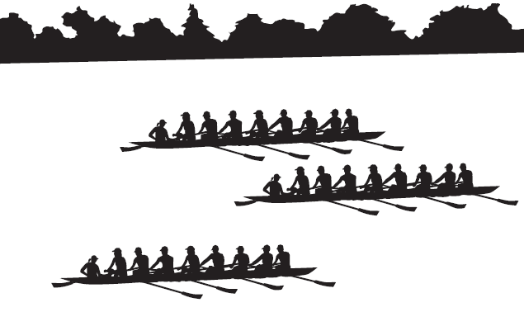

a) What is the total number of people competing in the boat race?

45 people

There are 90 people signed up for next week’s boat race. The rules say that each boat must have 9 people.

b) Write an equation that shows how to find the number of boats in the race.

Correct equations include:
- 9 × ___ = 90
- 90 $÷$ 9 = n
- 90 $÷$ 9 = 10
- 9 × 10 = 90

Error Analysis 3a:
- Students who answered 12 or 14 added the number of boats to the number of people in a boat and may need help recognizing equal group situations as multiplication.
- Students who answer 27 understand how to find the number of objects in a group but did not understand this situation well enough. These students may have overlooked that there were 5 boats in the race. These students may benefit from practice translating stories into visual models.
- Students who answered between 40 and 50 knew this was a multiplication situation but may need more work with multiplication facts involving 5.

Error Analysis 3b:
- Students who used addition or multiplication equations (besides missing factors equations) may need more time working with the idea of total number of objects in order to see division applications more easily.
- Students who answer between 7 and 12 may recognize this as a division situation but are not familiar enough to recognize this as a 10 fact.

Lesson 11

Fact Practice 3

Standard(s): 3.OA.C.7 (Major work)

Learning goal/objective: Accurately determine products within 100 and their related quotients. Develop speed with 0, 1, 2, 5, and 10 facts.

Aspect(s) of rigor addressed: Procedural Skill and Fluency

Overview
The last lesson in the unit returns to fact practice with a specific focus on the 0, 1, 2, 5, and 10 facts. Students revisit the concept of commutativity in the context of fluency. By the end of the lesson, students should demonstrate fluency with 0, 1, and 10 facts. These and other facts will continue to be practiced throughout the year.

Opportunities to connect to Standards for Mathematical Practice:
Students will use repeated reasoning (MP.8) to begin to develop speed with facts including numbers for which they know the skip counting sequence.

Tasks and discussion questions:
- Have students practice finding products within 100, with about 75% of the facts involving 0, 1, 2, 5, and 10. Problems are all numerical but take a variety of formats (see problems provided).
- Have students sort facts into ones they know and ones they still need to practice. Discuss strategies for finding the product for multiplication facts with the first factor being 2 or 5 and the second factor being relatively large (e.g., 2 × 9 or 5 × 7).
- Summarize the lesson by asking students to reflect on how many multiplication facts they can answer quickly and correctly. Let them know that they will continue working to get better at knowing their facts so that they know them all by the end of the year.

Challenges to anticipate:
- Students will likely be at very different places with their fluency. Teachers should monitor how students are answering the problems and work individually with students to move them toward fluency. Students who have automatic recall should be encouraged to simply write the answer. Students who are hung up on less efficient methods should be encouraged to look for facts they may have memorized. Students who don’t have memorized facts should look for patterns to help them both memorize facts and move to more efficient methods.
A note about activities to develop fluency:
The games featured in lesson 9 can be revisited for additional practice.
Lesson 11
Discussion, formative assessment and practice

1. Find the product:

a) 9 × 2 = 18

c) 24 = 6 × 4
b) 0 = 8 × 0

d) 5 × 10 = 50

2. Find the quotient:

a) 20 ÷ 5 = 4

c) 6 = 12 ÷ 2
b) 7 = 7 ÷ 1

d) 100 ÷ 10 = 10

3. Find the missing value in each equation:

a) 8 × 5 = 40

c) 49 = 7 × 7

e) 2 × 2 = 4
b) 18 = 2 × 9

d) 8 = 8 × 1

f) 64 ÷ 8 = 8

4. This lesson focused on facts using 0, 1, 2, 5, and 10. Which facts can you recall? Which facts take you more time? Why?

Answers will vary

Summative Assessment

Timing: Overall, this assessment (both sections 1 and 2) is intended to take about 35–40 minutes.

Sample instructions for Section 1:
You will have 2 minutes to answer as many of these questions as you can in pen. After I call 2 minutes, switch to pencil to complete the rest of the fluency problems. You may do the problems in any order you choose. After completing the fluency section, you may switch back to pencil to complete the assessment.

Use the answers to the fluency section to guide fluency instruction in future work on multiplication. Students are not expected to complete all 30 problems in 2 minutes at this time. Students should progress throughout the year with their fluency of one-digit multiplication facts.

Section 1: Fact Fluency

2 × 2 = 4 | 1 × 10 = 10
10 × 3 = 30 | 8 × 2 = 16
5 × 1 = 5 | 0 × 3 = 0
5 × 5 = 25 | 7 × 10 = 70
8 × 5 = 40 | 5 × 6 = 30
15 = 5 × 3 | 5 × 2 = 10
3 × 2 = 6 | 8 × 0 = 0
5 × 10 = 50 | 10 × 4 = 40
7 × 5 = 35 | 4 × 2 = 8
2 × 6 = 12 | 9 × 1 = 9
8 = 8 × 1 | 4 × 5 = 20
1 × 6 = 6 | 9 × 5 = 45
0 × 10 = 0 | 2 × 9 = 18
7 × 1 = 7 | 10 × 2 = 20
2 × 7 = 14 | 100 = 10 × 10

Section 2: Working with Equal Groups
Answer all 12 questions.

1. Circle each picture that shows equal groups. (Lesson 1)
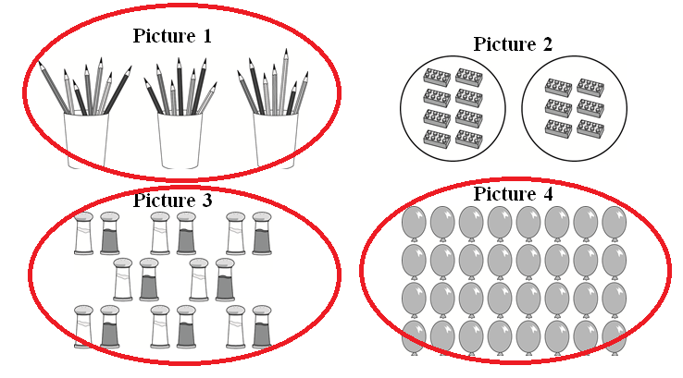

2. Packs of juice boxes are shown below. (Lessons 1, 2)
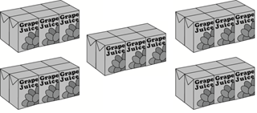

a) How many equal groups are there?

5 equal groups

c) How many juice boxes are there total?

30 total

b) How many juice boxes are in each group?

6 in each group

d) Write a multiplication equation that describes the arrangement of juice boxes.

5 × 6 = 30

3. There are 5 bowls with 4 grapes in each bowl. How many grapes are there altogether?
5 × 4 = 20

20 grapes altogether

4. Rearrange the flowers in Parker’s vases so each has an equal number of flowers: (Lesson 6)

Parker’s Flowers New Flower Arrangement

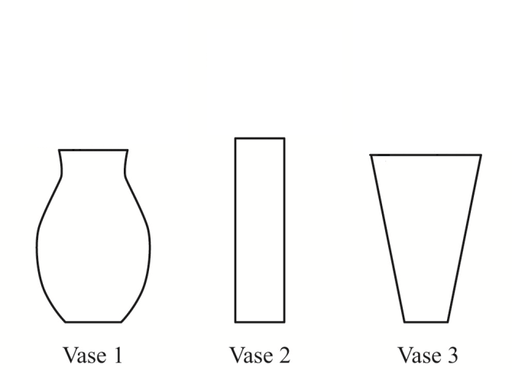
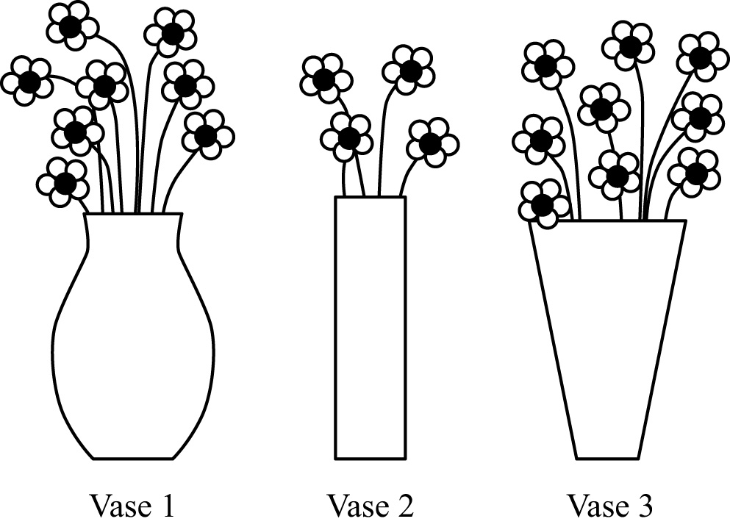

(Each vase should have 7 flowers)

b) Write an equation to represent the new arrangement of Parker’s flowers.
3 × 7 = 21

5. Mrs. Oro needs 90 corn seeds. The Garden Center sells corn seeds in packs of 10 seeds each. (Lessons 7, 8, 10)

a) Write a division equation showing how many packs of seeds Mrs. Oro should buy.

Correct equations include:
- 90 ÷ 9 = 10
- 90 ÷ 10 =__
- 90 ÷ n = 10
- 90 ÷ 10 = 9

c) Write a multiplication equation showing how many packs of seeds Mrs. Oro should buy.

Correct equations include:
- 9 × 10 = 90 (preferred)
- _ × 10 = 90
- 10 × _ = 90
- 10 × 9 = 90
b) Identify the quotient in your equation above by circling it.

See bolded quotients in part a.

d) Identify the product in your equation above by circling it.

See bolded factors in part c.

6. What is the unknown in each of the four equations below? (Lessons 9, 11)

a) 21 ÷ 7 = = 3
c) 8 × □ = 56 □ = 7

b) × 6 = 36 = 6
d) H ÷ 3 = 4 H = 12

7. Ken says that every time you multiply the product is greater than both factors.

Ken is wrong. To convince Ken that the product of two numbers is sometimes, but not always, greater than each of the factors. (Lessons 2, 3)

a) Write an equation where the product is greater than both factors.

One equation with both factors greater than 1, correct equations include:
- 2 × 2 = 4
- 3 × 10 = 30.

b) Write an equation where the product is less than or equal to both factors.

One equation with one or both factors equal to 0 or 1, correct equations include

- 0 × 1 = 0
- 1 × 2 = 2

8. In which situation is the number of plums equal to 58 × 29? (Lesson 3)

a) Sam buys 58 plums and puts 29 plums in each bag.
b) Ron buys 58 bags with 29 plums in each bag.
c) Tim buys 58 plums and gives 29 of the plums away.

d) Dan has 58 plums and buys 29 more plums.

9. Mrs. Ling puts 30 students in teams of 5 students each. (Lessons 3, 8)

a) Draw a diagram that shows how Mrs. Ling arranged the students:

Sample diagram:

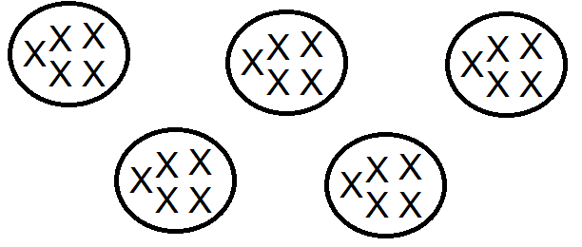
b) Write an equation that describes the arrangement of students.

Correct equations include:
30 ÷ 5 = 6
30 ÷ 6 = 5

10. Mrs. Shapiro has 28 markers. She has red, blue, yellow, and black markers. She has the same number of markers in each color

a) How many markers does Mrs. Shapiro have?

7 markers in each

b) Show your work or describe how you found your answer here:

Adequate work can include words, equations, or visual models detailing 28 ÷ 4 = 7

11. Amy and Bonnie are putting an equal number of stickers into 5 sticker books. They have 100 stickers. Amy wrote the following division equation to find the number of stickers to put in each sticker book:

100 $÷$ 5 = ____

Bonnie wrote the following multiplication equation to find the number of stickers to put in each sticker book:

5 × ____ = 100
(Lessons 6, 8)

a) Who is correct? (Circle one answer)

Neither person Amy Bonnie Both People

b) Explain your answer.
Sample answer:
I know the solution to 100 ÷ 5 = ? is the same as ? × 5 = 100.

12. Describe a situation that could match the following equation: 10 ÷ 1 = 10 (Lesson 8)

Any situation that entails dividing 10 things into 1 group of 10

1. For more information on the Major Work, see http://achievethecore.org/page/774/focus-by-grade-level
2. This unit is part of the Grade 3 Course Blueprint from Illustrative Mathematics available at http://www.illustrativemathematics.org/blueprints/3
3. Task from: https://www.illustrativemathematics.org/illustrations/1531

